VIDEO RENTAL STORE SYSTEM

**SEQUENCE DIAGRAMS**

1. Disk rental and return management

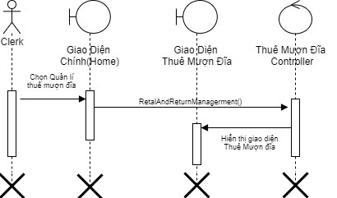

1a. Rent Disk

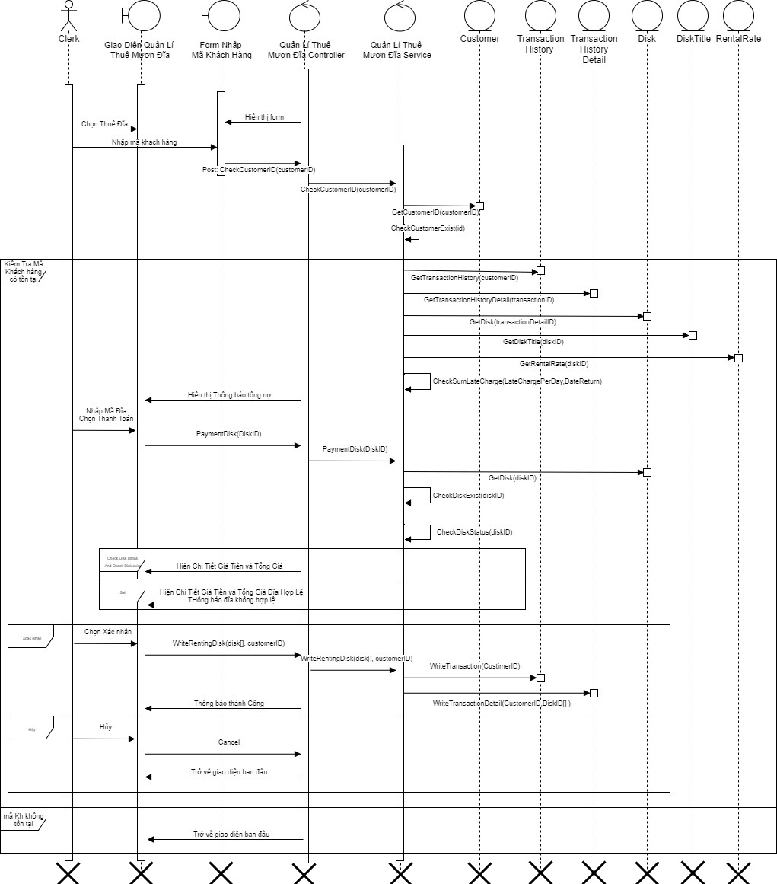

1b. Record the return Disk

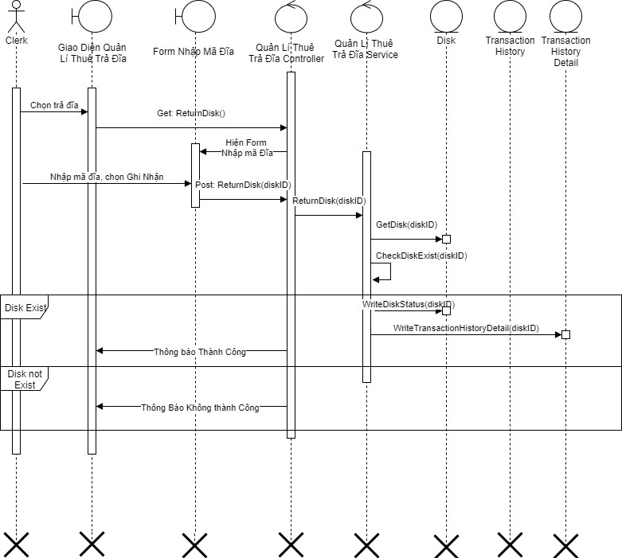

1c. Report Disk status

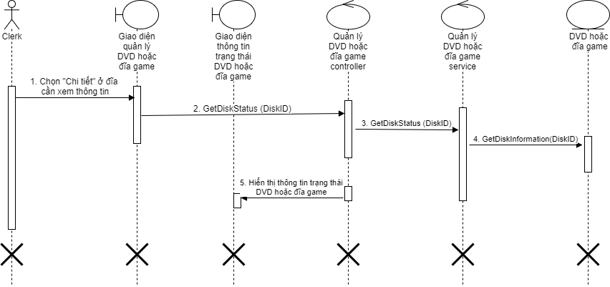

2. Customer management



2a. Add new Customer



2b. Update Customer information



2c. Delete a Customer



3. Title management



3a. Add new Title



3b. Delete a Title



3c. Show information about a paticular title

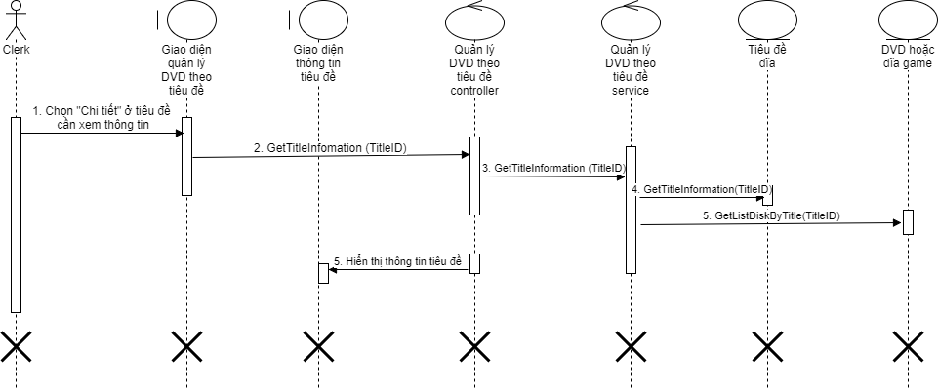

4. Disk manageent



4a. Add new Disk



4b. Delete a Disk



4c. Update Disk information



5. Late charge management

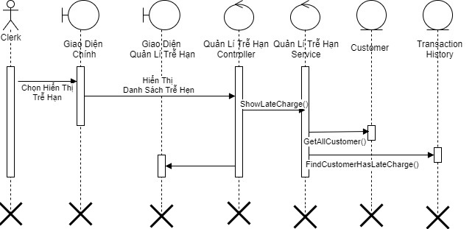

5a. Add late charge

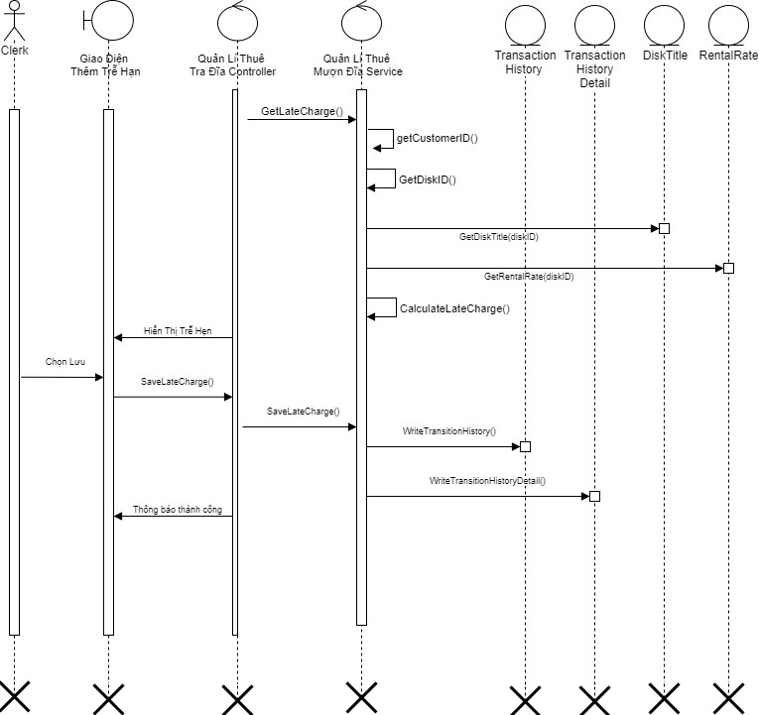

5.c Record the Late charge payment of particular Customer

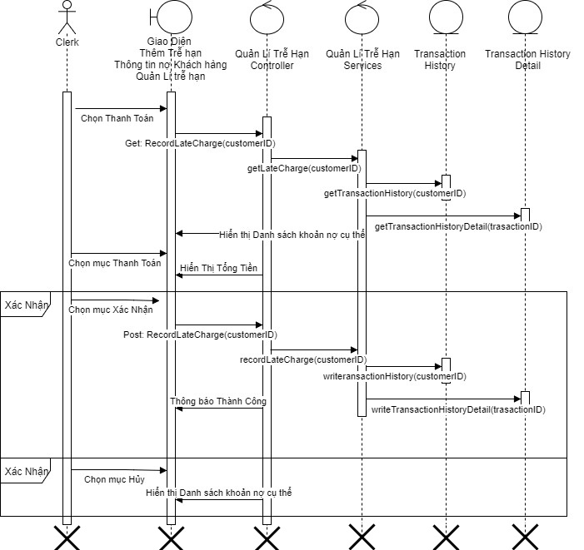

5d. Show in formation about Customer late charges

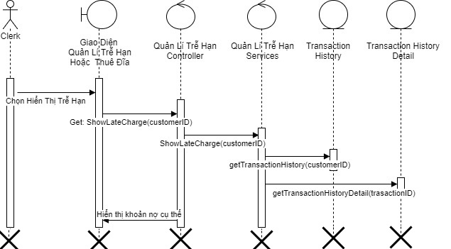

5e. Cancel a specific late charge

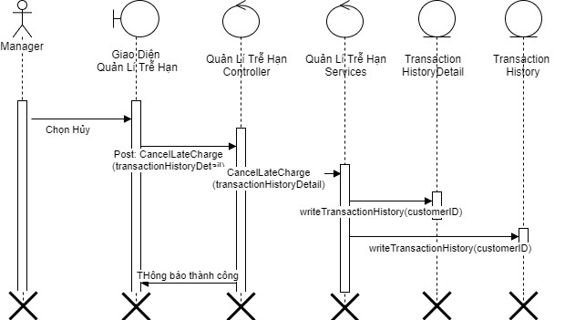

6. Reservation Management

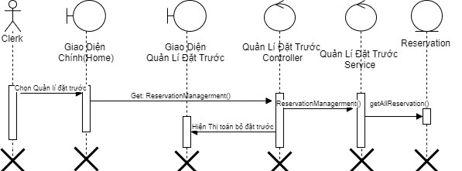

6a. Enter a reservation for a Title

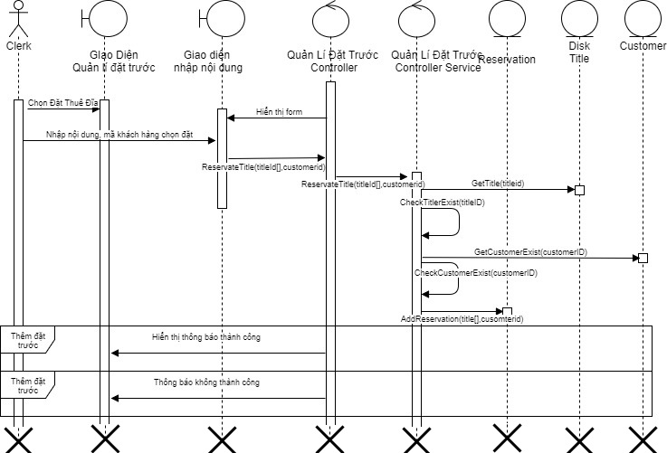

6b. Place a newly return Disk “on hold” for the first customer reservation

(Auto)

6c. Cancel a reservation

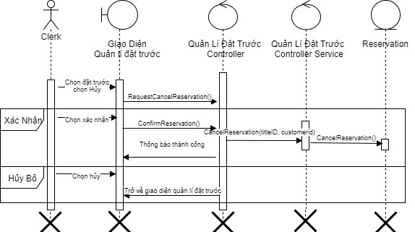

7. Report

7.1 Produce a Customer report

7.1a: Report all Customers

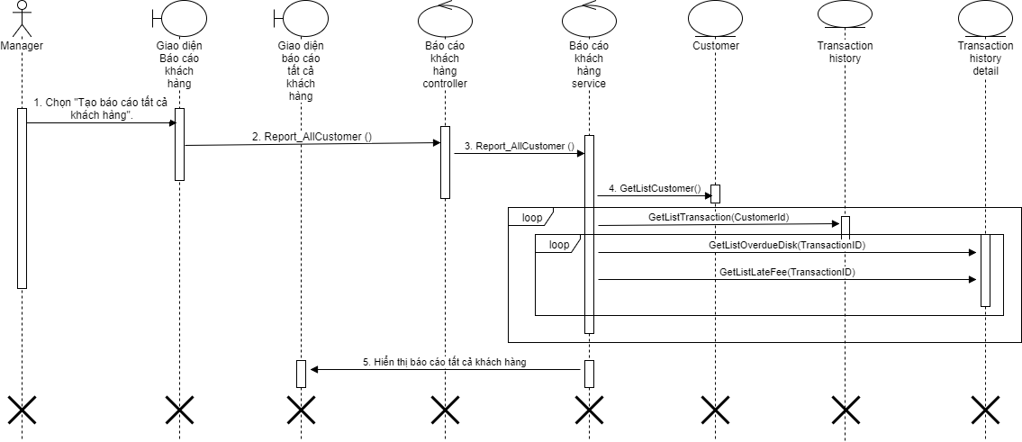

7.1b: Report one Customers have one or more overdue items

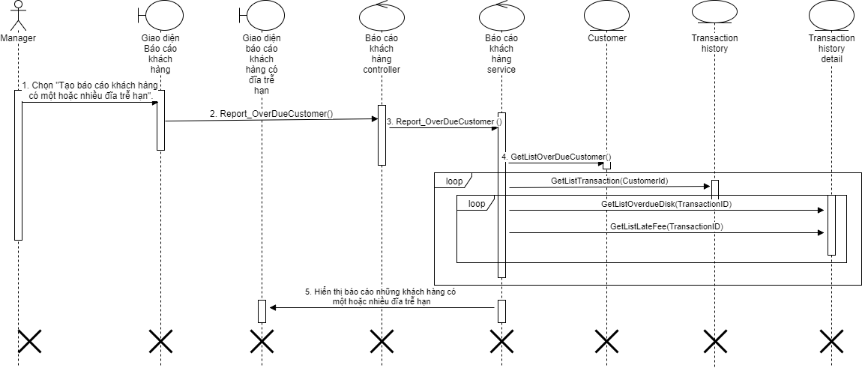

7.1c: Report Customers that owe one or more late fees

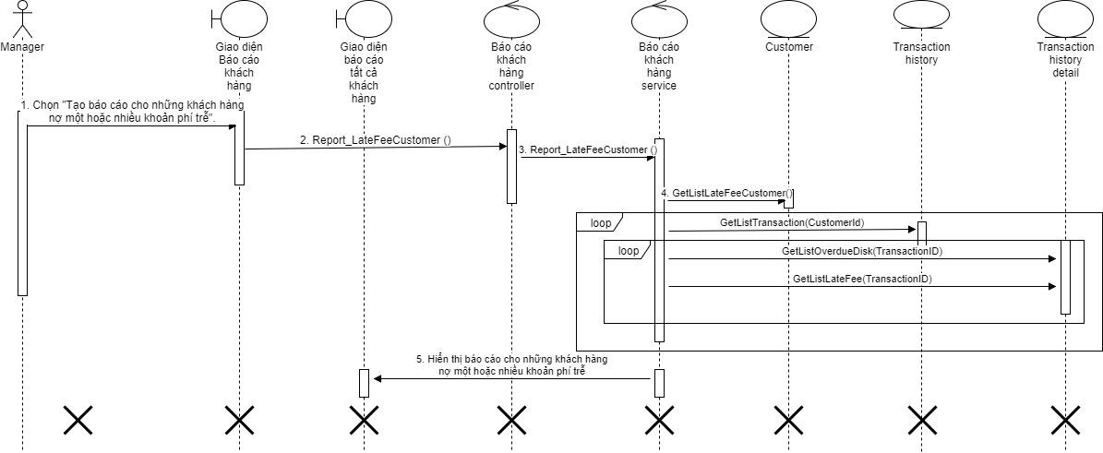

7.2 Procduce a Title report

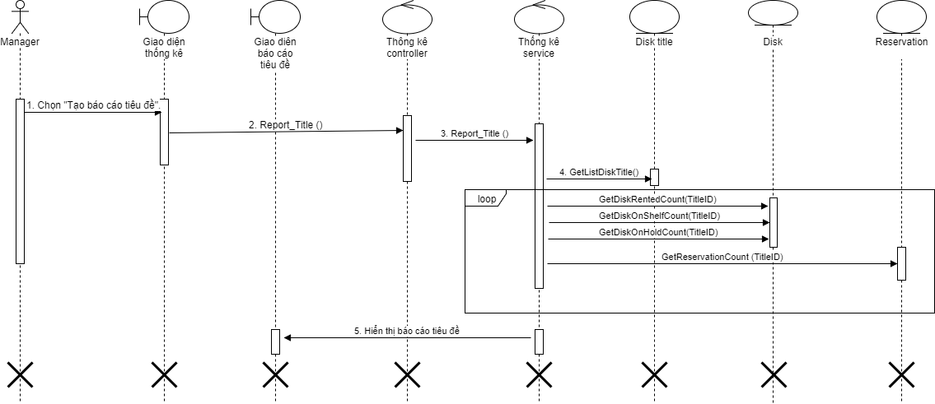

8. Rental rate management

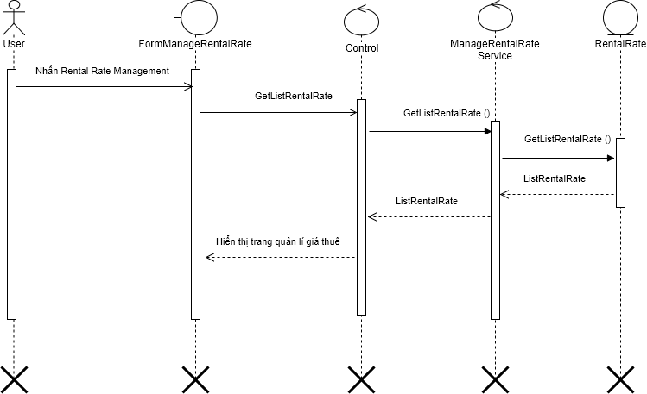

8a. Set rental price and period



9. Login

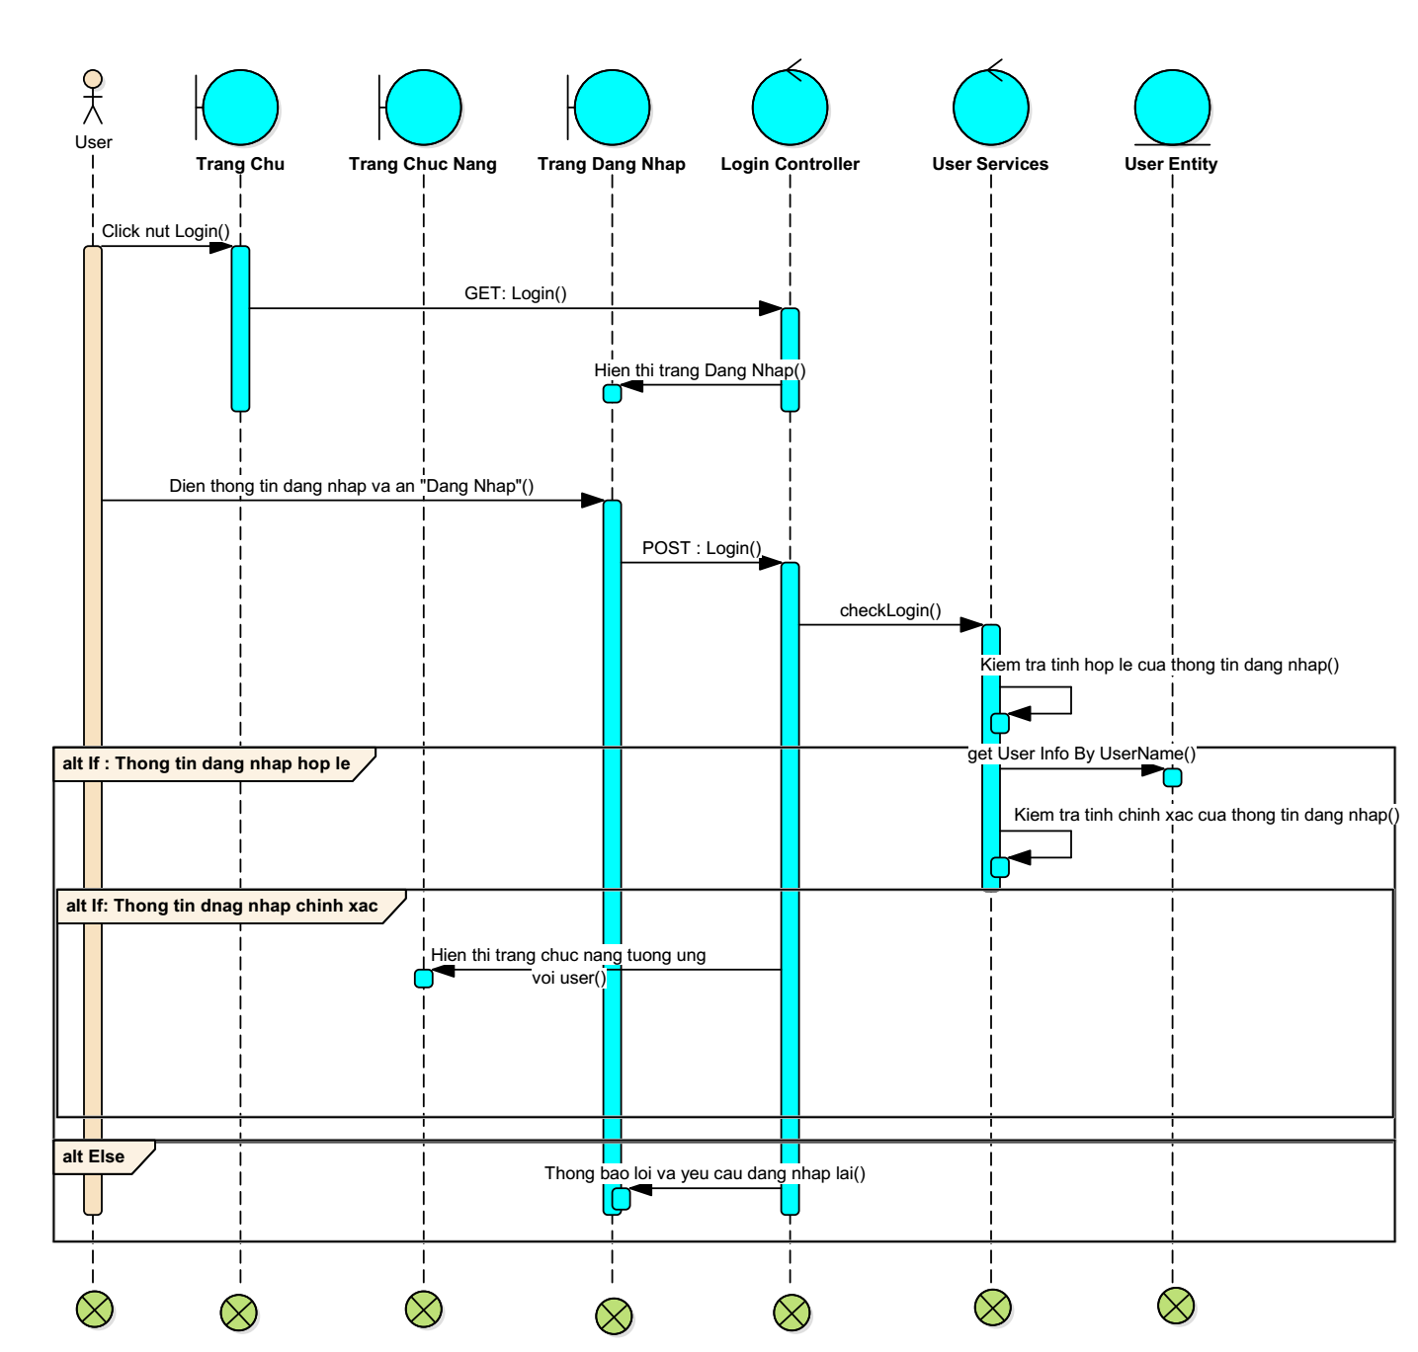

10. Logout

